Appendix
Table A1: Considered Newspapers as Source of Political Advertisements
Name of Newspaper | Language region | Canton | Issues per week
20 Minuten ^{a)} | German | Supraregional | 5
20 minutes ^{a)} | French | Supraregional | 5
20 minuti | Italian | TI | 5
24 heures | French | VD | 6
Aargauer Zeitung | German | AG | 6
Appenzeller Volksfreund | German | AI | 3
Appenzeller Zeitung | German | AR | 6
Basellandschaftliche Zeitung | German | BL | 6
Basler Zeitung | German | BS | 6
Berner Zeitung | German | BE | 6
Blick | German | Supraregional | 6
Blick am Abend | German | Supraregional | 5
Bote der Urschweiz | German | SZ | 6
Bund, Der | German | BE | 6
Caffè, Il | Italian | TI | 1
Corriere del Ticino | Italian | TI | 6
L’Express | French | NE | 6
Le Temps | French | GE | 6
Liberté, La | French | FR | 6
Matin Dimanche, Le | French | Supraregional | 1
Matin, Le | French | Supraregional | 6
Mattino della Domenica, Il | Italian | TI | 1
Neue Luzerner Zeitung | German | LU | 6
Neue Nidwaldner Zeitung | German | NW | 6
Neue Obwaldner Zeitung | German | OW | 6
Neue Urner Zeitung | German | UR | 6
Neue Zuger Zeitung | German | ZG | 6
Neue Zürcher Zeitung | German | ZH | 6
Nouvelliste, Le | French | VS | 6
NZZ am Sonntag | German | Supraregional | 1
Ostschweiz am Sonntag | German | SG | 1
Quotidien Jurassien, Le | French | JU | 6
Regione Ticino, La | Italian | TI | 6
Schaffhauser Nachrichten | German | SH | 6
Schweiz am Sonntag ^{a)} | German | Supraregional | 1
Solothurner Zeitung | German | SO | 6
SonntagsBlick | German | Supraregional | 1
SonntagsZeitung | German | Supraregional | 1
St.Galler Tagblatt | German | SG | 6
Südostschweiz, Die ^{a)} | German | Supraregional | 6
Tages-Anzeiger | German | ZH | 6
Thurgauer Zeitung | German | TG | 6
Tribune de Genève | French | GE | 6
Walliser Bote | German | VS | 6
Zentralschweiz am Sonntag ^{a)} | German | Supraregional | 1
Notes: ^{a)} For these outlets, the database on political advertisements contained information on political advertisements in various regional editions of the newspapers (APS 2016). To individuals who indicated that they have considered this journal, we attributed campaign figures of the regional outlets when they have their domicile in a canton where a regional paper is edited. If this was not the case, an individual’s campaign exposure was calculated by taking the mean value of advertisements placed in all regional editions.

Table A2: Operationalization and Summary Statistics for all Utilized Variables
Variable | Operationalization | Summary stats
Vote intention at wave 1 | No intention to vote (0), intention to vote for the FDP (1), for the SVP (2) or for another party (3) | (0) 6.85%; (1) 21.22%; (2) 18.72%; (3) 53.20%
Vote intention at wave 2 | Intention to vote for another party (0), for the FDP (1), for the SVP (2). | (0) 60.26%; (1) 20.46%; (2) 19.28%.
CIO EU – SVP (w2) | Is the SVP the most competent party to handle the issue of EU? Opinion at wave 2. No (0); Yes (1) | (0) 84.48%;  (1) 15.52%
CIO EU – SVP (w1) | Is the SVP the most competent party to handle the issue of EU? Opinion at wave 1. No (0); Yes (1) | (0) 86.10%;  (1) 13.90%
CIO EU – FDP (w2) | Is the FDP the most competent party to handle the issue of EU? Opinion at wave 2. No (0); Yes (1) | (0) 70.85%;  (1) 29.15%
CIO EU – FDP (w1) | Is the FDP the most competent party to handle the issue of EU? Opinion at wave 1. No (0); Yes (1) | (0) 70.97%;  (1) 29.03%
CIO Migration – SVP (w2) | Is the SVP the most competent party to handle the issue of migration? Opinion at wave 2. No (0); Yes (1) | (0) 75.66%;  (1) 24.34%
CIO Migration – SVP (w1) | Is the SVP the most competent party to handle the issue of migration? Opinion at wave 1. No (0); Yes (1) | (0) 74.81%;  (1) 25.19%
CIO Migration – FDP (w2) | Is the FDP the most competent party to handle the issue of migration? Opinion at wave 2. No (0); Yes (1) | (0) 89.99%;  (1) 10.01%
CIO Migration – FDP (w1) | Is the FDP the most competent party to handle the issue of migration? Opinion at wave 1. No (0); Yes (1) | (0) 91.56%;  (1) 8.44%
CIO Economy – SVP (w2) | Is the SVP the most competent party to handle the issue of economy? Opinion at wave 2. No (0); Yes (1) | (0) 91.78%;  (1) 8.22%
CIO Economy – SVP (w1) | Is the SVP the most competent party to handle the issue of economy? Opinion at wave 1. No (0); Yes (1) | (0) 92.80%;  (1) 7.20%
CIO Economy – FDP (w2) | Is the FDP the most competent party to handle the issue of economy? Opinion at wave 2. No (0); Yes (1) | (0) 49.87%;  (1) 50.13%
CIO Economy – FDP (w1) | Is the FDP the most competent party to handle the issue of economy? Opinion at wave 1. No (0); Yes (1) | (0) 51.03%;  (1) 48.97%
Female | (0) male; (1) female | (0) 55.64%  (1) 44.36%
Age | Age in years | Mean: 50.06  SD: 16.47
Religious affiliation | (0) No religious affiliation; (1) Catholic; (2) Protestant; (3) Other | (0) 27.19%; (1) 35.27%; (2) 32.63%; (3) 4.91%
Education | 13-point scale from (1) no education to (13) University, Federal institute of technology | Mean: 8.90  Median: 10  SD: 3.30
Income | Gross monthly household income. 15-point scale from (1) Less than 2000 CHF to (15) Over 15'000 CHF | Mean: 8.19  Median: 8  SD: 3.90
Ideological orientation | Left-Right Self-Placement from (0) left to (10) right. | Mean: 5.26  Median: 5  SD: 2.56
Language region | (1) German; (2) French; (3) Italian | (1) 72.63%  (2) 23.16%  (3) 4.20%
MIP: EU | Percentage of respondents in our sample indicating that they regard the EU to be the most important issue. | (0) 88.30%  (1) 11.70%
MIP: Economy | Percentage of respondents in our sample indicating that they regard the economy to be the most important issue. | (0) 91.74%  (1) 8.26%
MIP: Immigration | Percentage of respondents in our sample indicating that they regard immigration to be the most important issue. | (0) 60.55%  (1) 39.45%
Issue preference: EU | Switzerland should become a member of the EU. (1) Strongly disagree; (0) somewhat disagree, neutral or (somewhat) agree. | (0) 58.08%  (1) 41.92%
Issue preference: Economy | The economy should be strengthened . (1) Strongly or rather agree; (0) neutral or disagree. | (0) 29.04%  (1) 70.96%
Issue preference: Immigration | Immigration should be limited. (1) Strongly or rather agree; (0) neutral or disagree. | (0) 44.62%  (1) 55.38%
SVP: Presence in ads | Square root of the total amount of SVP advertisements a respondent has been exposed to until the date of the second interview (for more details of the coding, see above). | Mean: 2.31  SD: 2.14  Min: 0  Max: 10.95
FDP: Presence in ads | Square root of the total amount of FDP advertisements a respondent has been exposed to until the date of the second interview (for more details of the coding, see above). | Mean: 2.58  SD: 2.09  Min: 0  Max: 11
SVP: Immigration ads | Square root of the total SVP advertisements on immigration a respondent has been exposed to until the date of the second interview. | Mean: 1.43  SD: 1.24  Min: 0  Max: 4.36
SVP: Economy ads | Square root of the total SVP advertisements on economy a respondent has been exposed to until the date of the second interview. | Mean: 0.86  SD: 1.06  Min: 0  Max: 4.90
SVP: EU ads | Square root of the total SVP advertisements on the EU a respondent has been exposed to until the date of the second interview. | Mean: 1.30  SD: 1.15  Min: 0  Max: 4.12
FDP: Immigration ads | Square root of the total FDP advertisements on immigration a respondent has been exposed to until the date of the second interview. | Mean: 0.08  SD: 0.31  Min: 0  Max: 2.24
FDP: Economy ads | Square root of the total FDP advertisements on the economy a respondent has been exposed to until the date of the second interview. | Mean: 0.96  SD: 1.06  Min: 0  Max: 6.08
FDP: EU ads | Square root of the total FDP advertisements on the EU a respondent has been exposed to until the date of the second interview. | Mean: 0.13  SD: 0.47  Min: 0  Max: 4.69
Notes: Entries are based on observations included in our main model (Table 2; N=3402), with the exception of the CIO variables: These entries are based on the observations included in Table A.4.1- 4.6 in the Appendix.
Table A3. Stability in Vote Intention between Wave 1 and 2
 | FDP (w2) |  | SVP (w2) |  | Other (w2) |  | Total (w2)
 | N | in % | N | in % | N | in % | N | in %
No vote intention (w1) | 33 | 4.7 | 48 | 7.3 | 152 | 7.4 | 233 | 6.8
FDP (w1) | 566 | 81.3 | 23 | 3.5 | 133 | 6.5 | 722 | 21.2
SVP (w1) | 27 | 3.9 | 535 | 81.6 | 75 | 3.7 | 637 | 18.7
Other (w1) | 70 | 10.1 | 50 | 7.6 | 1690 | 82.4 | 1810 | 53.2
Total | 696 | 100.0 | 656 | 100.0 | 2050 | 100.0 | 3402 | 100.0
Notes: Only cases are considered that are part of the regression analysis (Table 2). Grey cells indicate the amount of stable vote intentions.

Table A4.1 Stability in Perceived Competence Issue Ownership (SVP-EU)
 | No (w2) |  | Yes (w2) |  | Total
 | N | in % | N | in % | N | in %
No (w1) | 3185 | 93.0 | 239 | 7.0 | 3424 | 100
Yes (w1) | 185 | 32.7 | 381 | 67.3 | 566 | 100
Total (w2) | 3370 | 84.5 | 620 | 15.5 | 3990 | 100
Notes: Only cases are considered that are part of the regression analysis (Table A9 in the Appendix). Grey cells indicate the amount of stable issue ownership perceptions.

Table A4.2 Stability in Perceived Competence Issue Ownership (FDP-EU)
 | No (w2) |  | Yes (w2) |  | Total
 | N | in % | N | in % | N | in %
No (w1) | 2393 | 85.3 | 413 | 14.7 | 2806 | 100
Yes (w1) | 415 | 35.1 | 769 | 64.9 | 1184 | 100
Total (w2) | 2808 | 70.4 | 1182 | 29.6 | 3990 | 100
Notes: Only cases are considered that are part of the regression analysis (Table A9 in the Appendix). Grey cells indicate the amount of stable issue ownership perceptions.

Table A4.3 Stability in Perceived Competence Issue Ownership (SVP-Migration)
 | No (w2) |  | Yes (w2) |  | Total
 | N | in % | N | in % | N | in %
No (w1) | 2826 | 91.3 | 269 | 8.7 | 3095 | 100
Yes (w1) | 304 | 29.2 | 738 | 70.8 | 1042 | 100
Total (w2) | 3130 | 75.7 | 1007 | 24.3 | 4137 | 100
Notes: Only cases are considered that are part of the regression analysis (Table A9 in the Appendix). Grey cells indicate the amount of stable issue ownership perceptions.

Table A4.4 Stability in Perceived Competence Issue Ownership (FDP-Migration)
 | No (w2) |  | Yes (w2) |  | Total
 | N | in % | N | in % | N | in %
No (w1) | 3560 | 94.0 | 228 | 6.0 | 3788 | 100
Yes (w1) | 163 | 46.7 | 186 | 53.3 | 349 | 100
Total (w2) | 3723 | 90.0 | 414 | 10.0 | 4137 | 100
Notes: Only cases are considered that are part of the regression analysis (Table A9 in the Appendix). Grey cells indicate the amount of stable issue ownership perceptions.

Table A4.5 Stability in Perceived Competence Issue Ownership (SVP-Economy)
 | No (w2) |  | Yes (w2) |  | Total
 | N | in % | N | in % | N | in %
No (w1) | 3512 | 95.0 | 183 | 5.0 | 3695 | 100
Yes (w1) | 148 | 50.2 | 147 | 49.8 | 295 | 100
Total (w2) | 3660 | 91.7 | 330 | 8.3 | 3990 | 100
Notes: Only cases are considered that are part of the regression analysis (Table A9 in the Appendix). Grey cells indicate the amount of stable issue ownership perceptions.

Table A4.6 Stability in Perceived Competence Issue Ownership (FDP-Economy)
 | No (w2) |  | Yes (w2) |  | Total
 | N | in % | N | in % | N | in %
No (w1) | 1509 | 75.3 | 495 | 24.7 | 2004 | 100
Yes (w1) | 457 | 23.0 | 1529 | 77.0 | 1986 | 100
Total (w2) | 1966 | 49.3 | 2024 | 50.7 | 3990 | 100
Notes: Only cases are considered that are part of the regression analysis (Table A9 in the Appendix). Grey cells indicate the amount of stable issue ownership perceptions.

Table A5. Pairwise Correlations between Campaign Variables (FDP)
FDP | Total | Economy | Migration | EU
Total
Economy | 0.7504
Migration | 0.3907 | 0.1981
EU | 0.4279 | 0.4058 | 0.2888
Notes: All campaign variables are operationalized as the square root of the absolute number of (issue-specific) advertisements. Only cases that are included in our main model (N=3402) are considered.

Table A6. Pairwise correlations between campaign variables (SVP)
SVP | Total | Economy | Migration | EU
Total
Economy | 0.8633
Migration | 0.9023 | 0.7854
EU | 0.9079 | 0.8357 | 0.9354
Notes: All campaign variables are operationalized as the square root of the absolute number of (issue-specific) advertisements. Only cases that are included in our main model (N=3402) are considered.
Table A7.1 Robustness Check for Hypothesis 1 - SVP
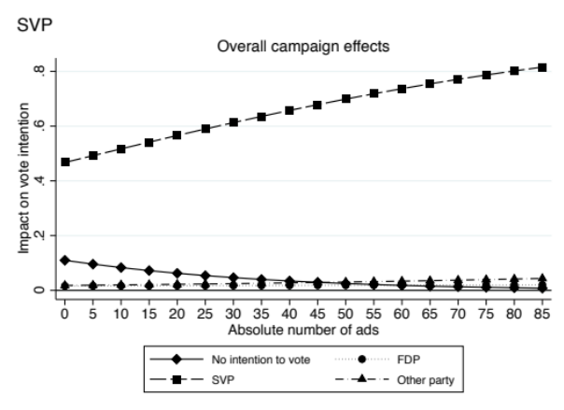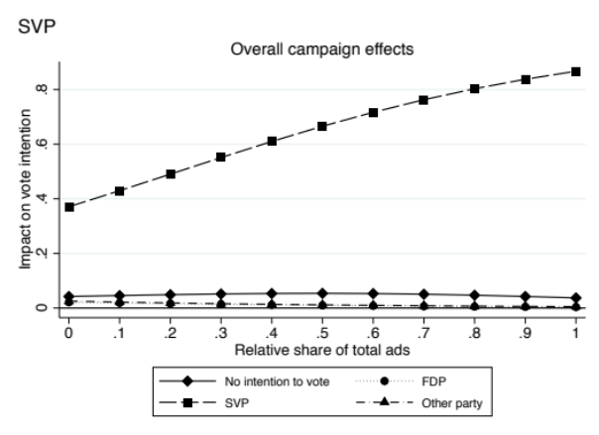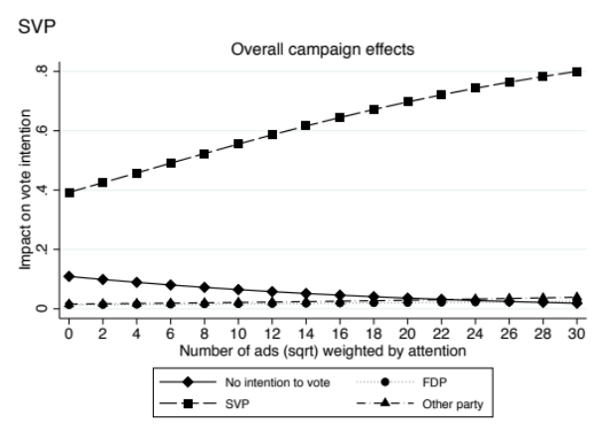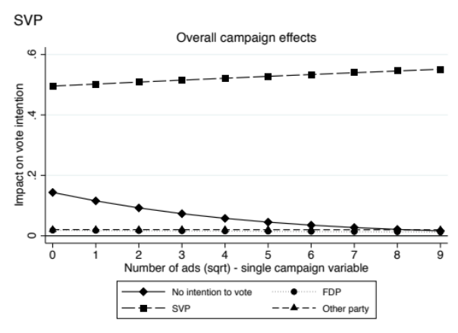

Table A7.2 Robustness Check for Hypothesis 1 - FDP
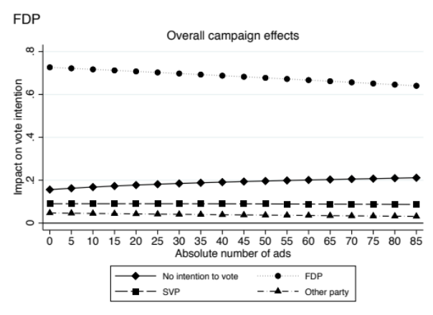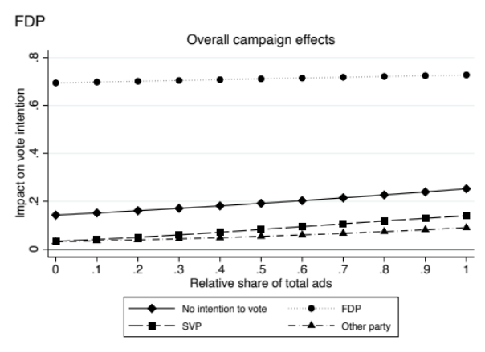
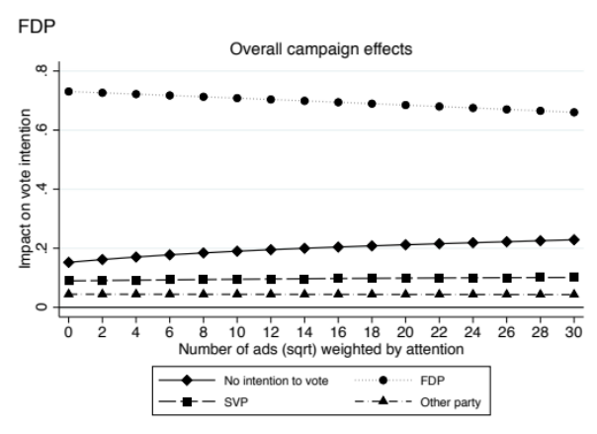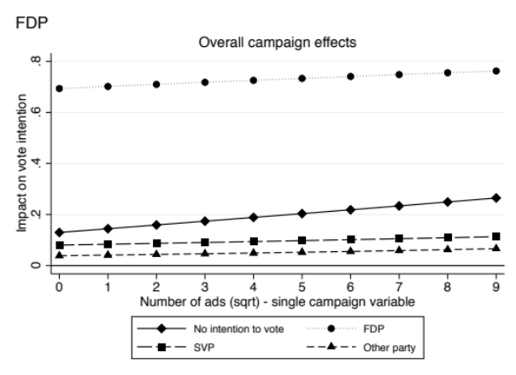
Table A7.3 Robustness Check for Hypothesis 2 – SVP
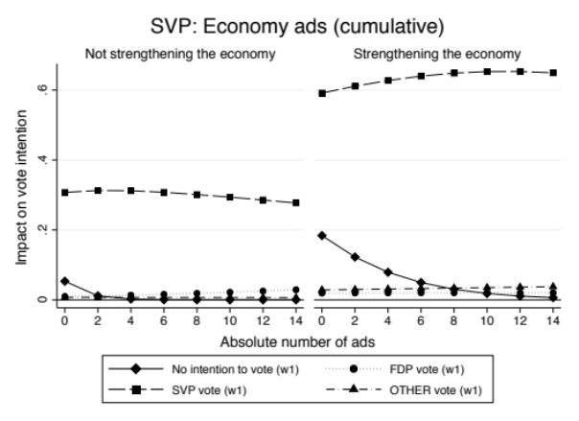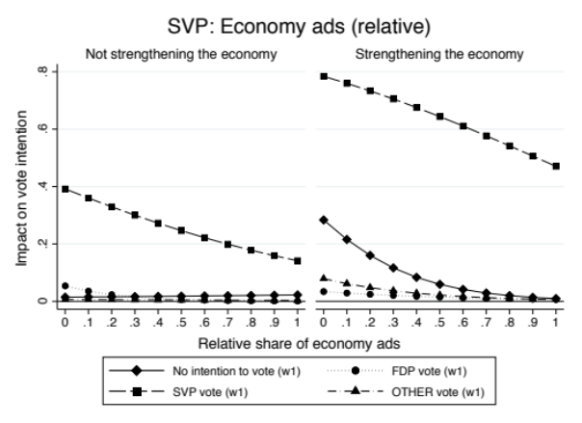
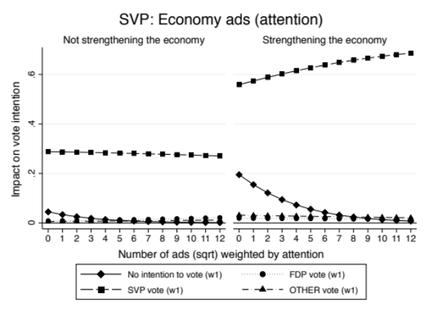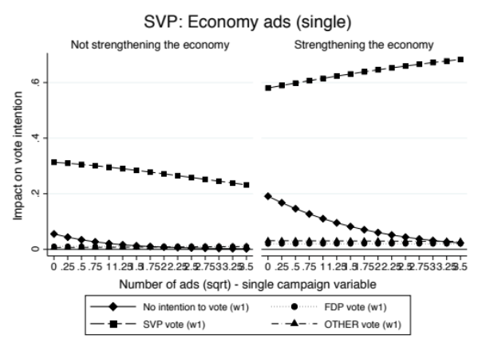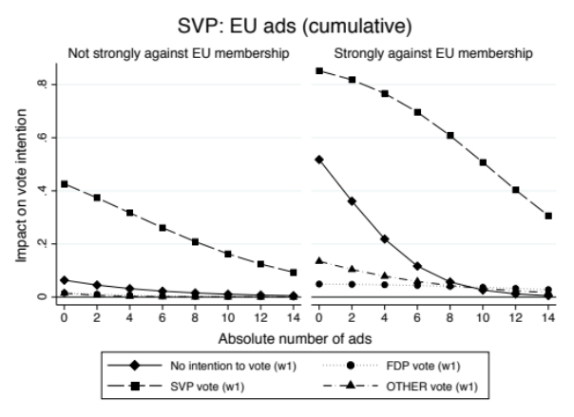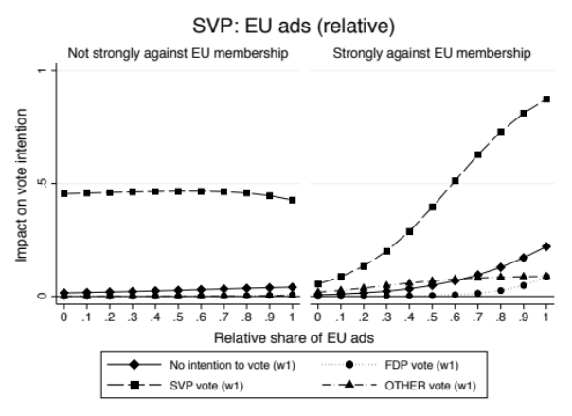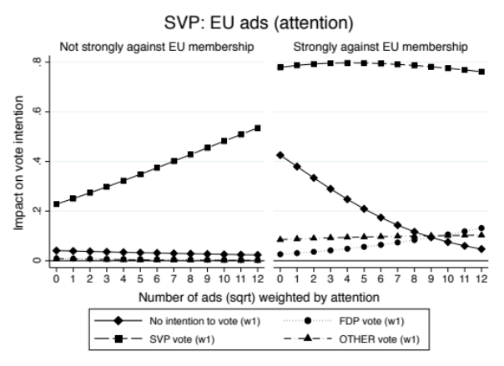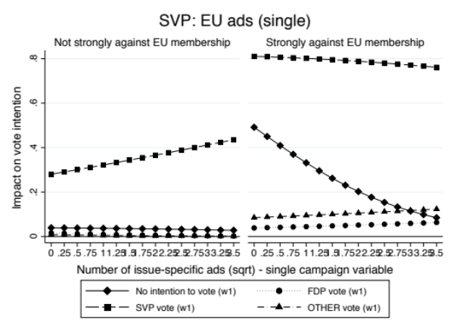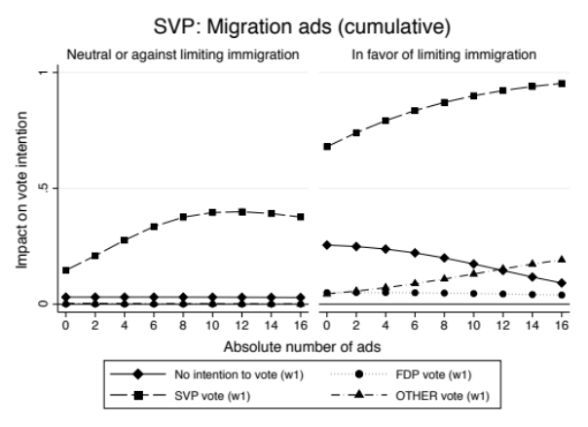
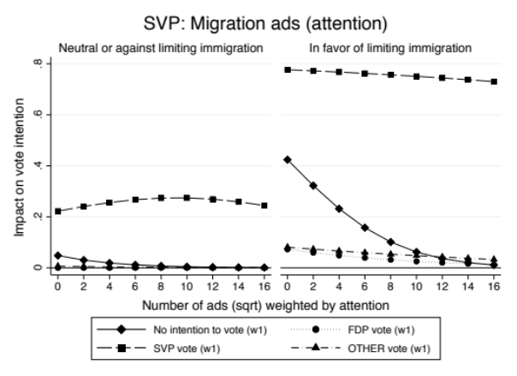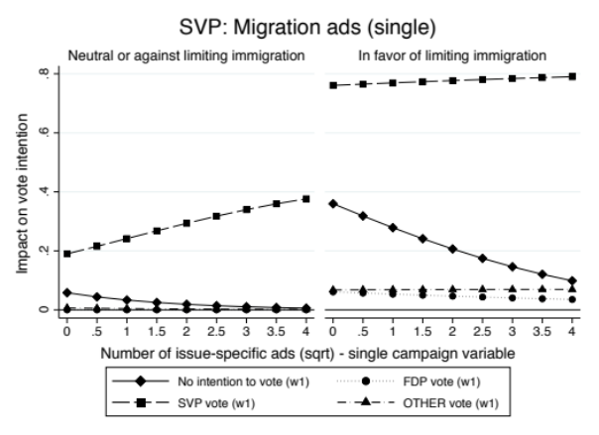
Table A7.4 Robustness Check for Hypothesis – FDP
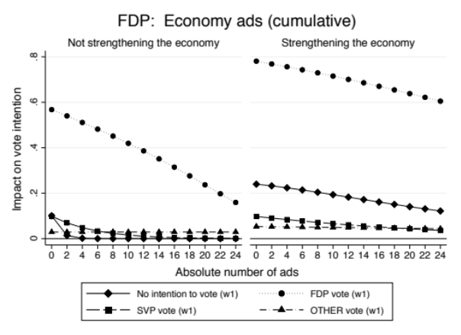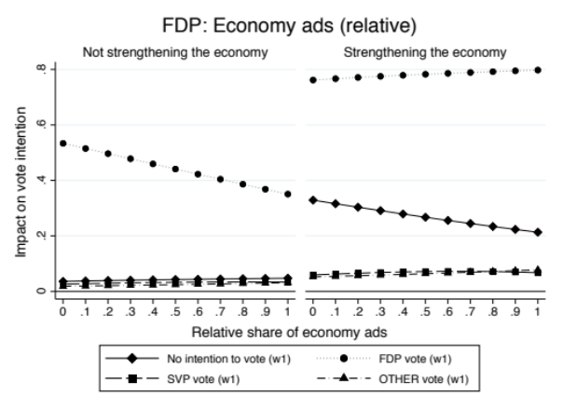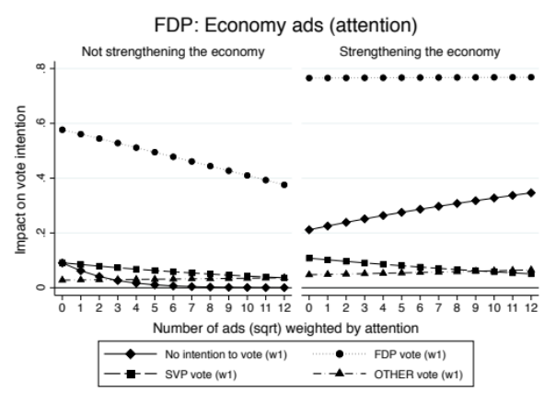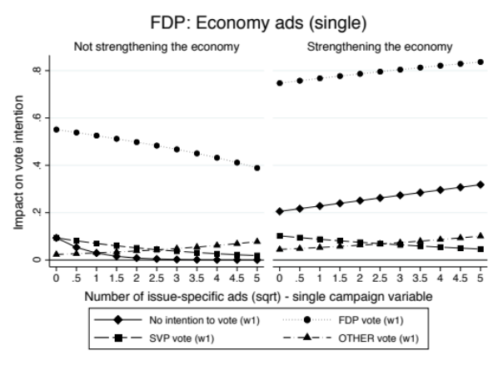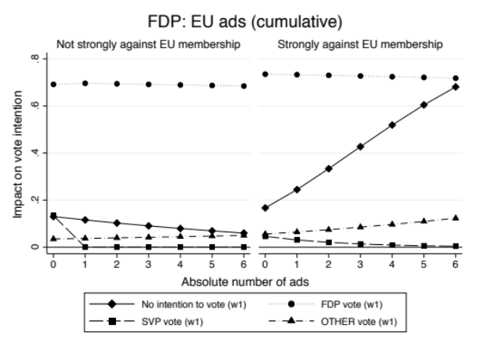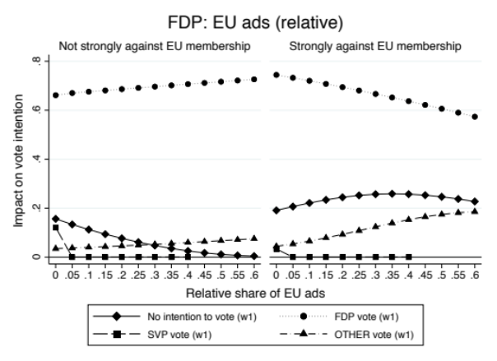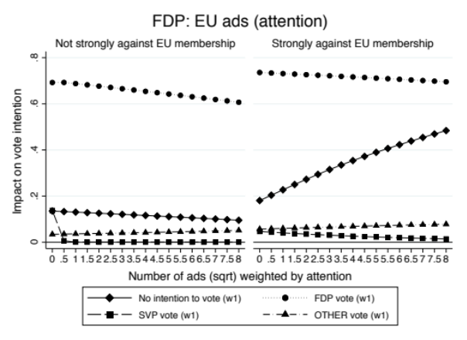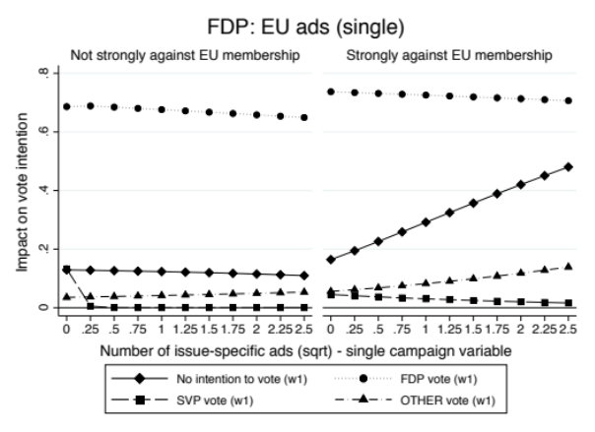
Table A7.5 Robustness Check for Hypothesis 3 – SVP
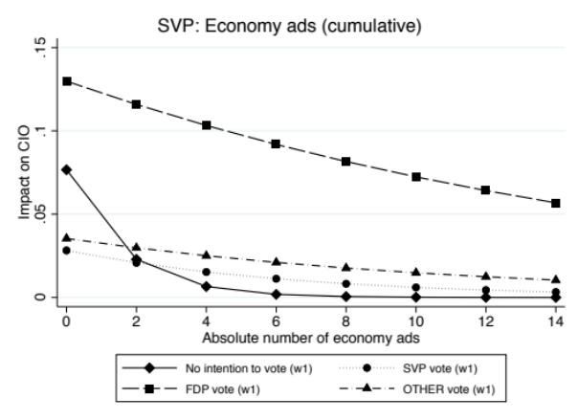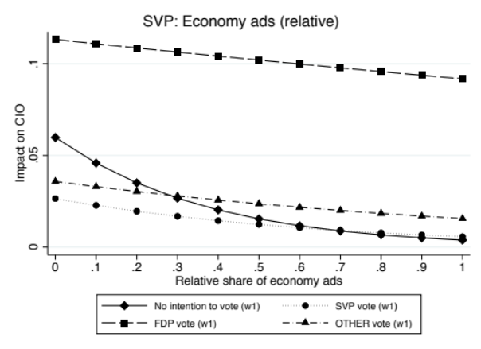
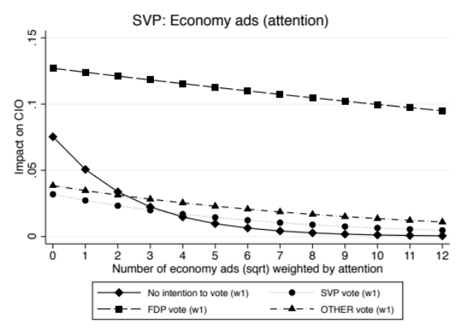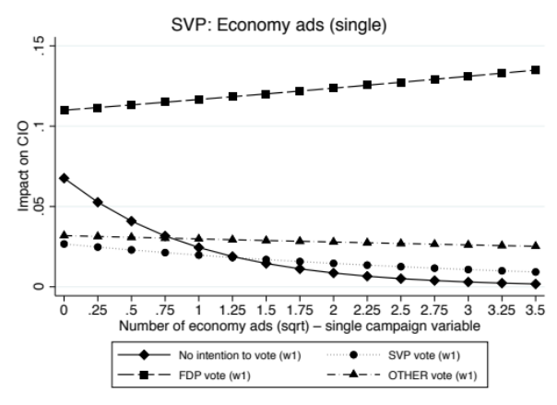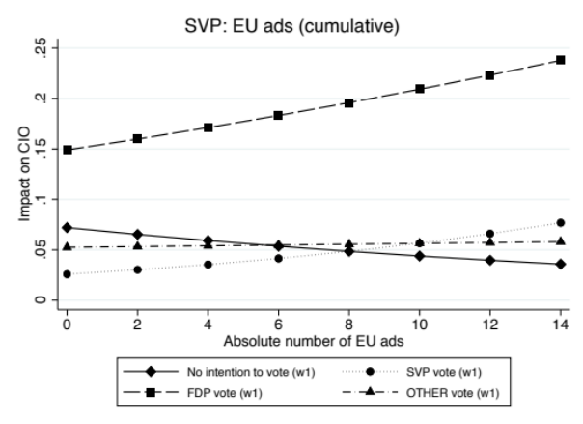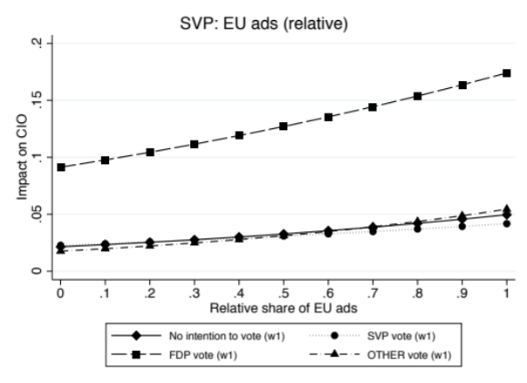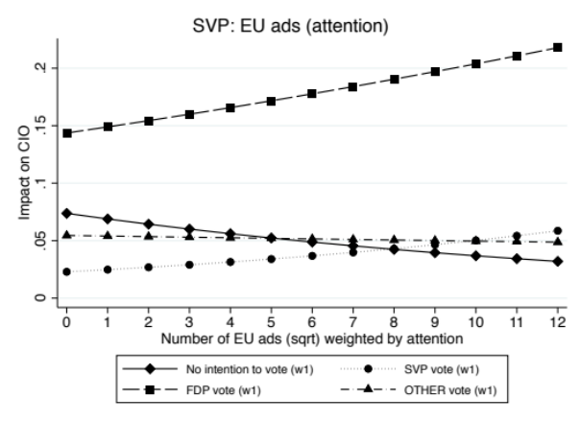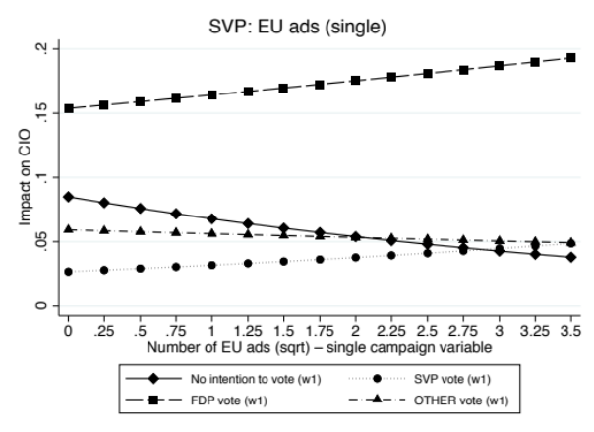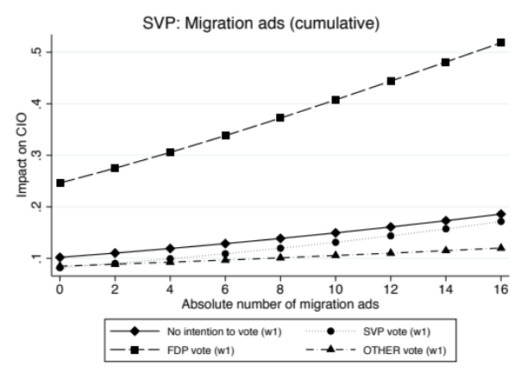
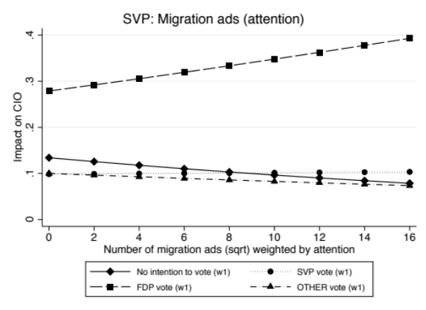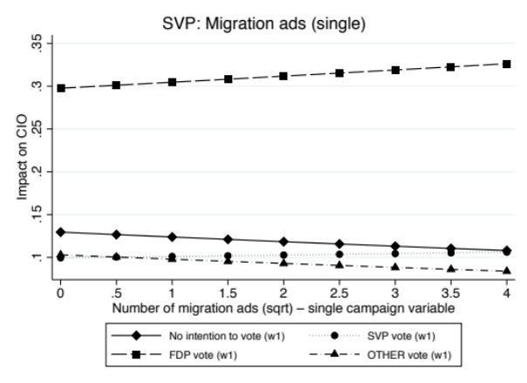
Table A7.6 Robustness Check for Hypothesis 3 – FDP
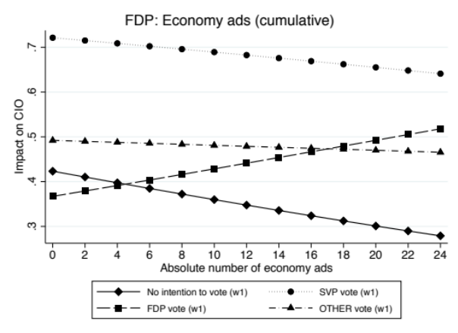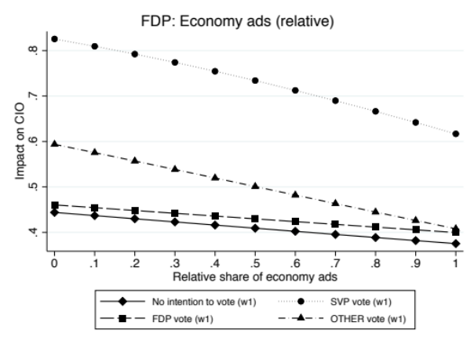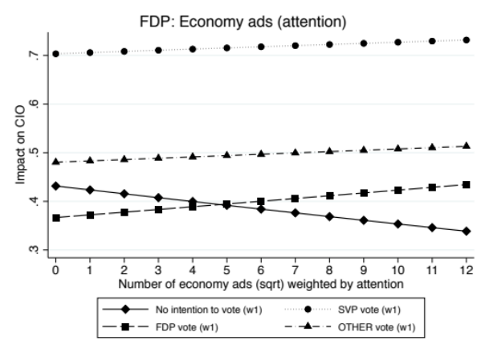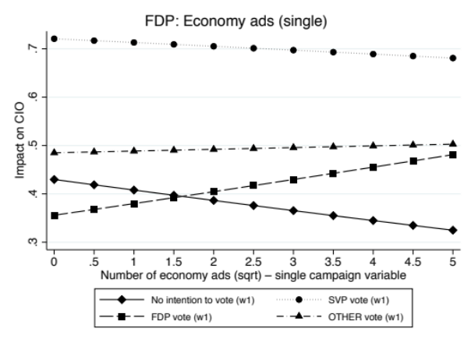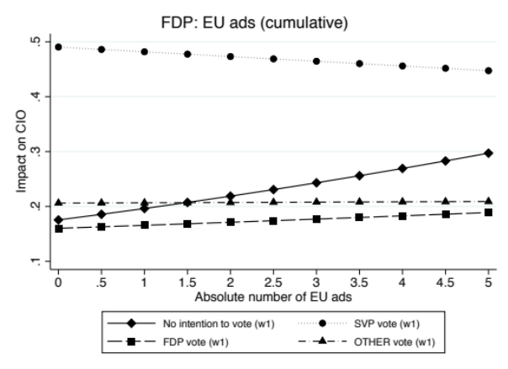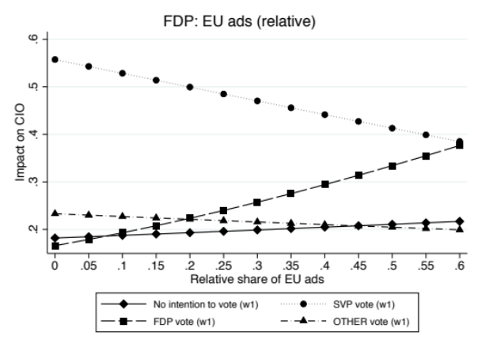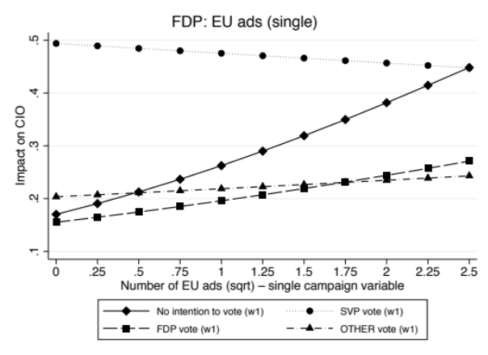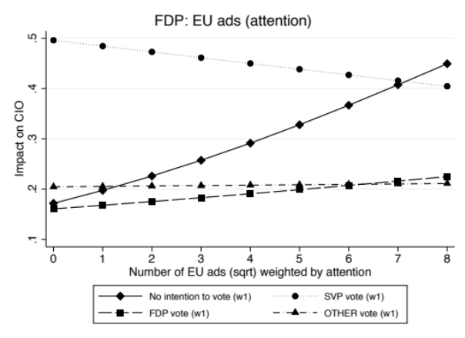
Table A8. Inter-Coder Agreement per Category
 | RCA | Kappa | s.e.
Topic: Migration | 100% | 1.000*** | 0.076
Topic: EU | 98.86% | 0.946*** | 0.076
Topic: Economy | 92.00% | 0.753*** | 0.073
Notes: Two coders independently coded N=175 randomly selected advertisements. *** p<0.001.
RCA = Overall rater coder agreement.

Table A9: Baseline Models for Competence Issue Ownership
 | Competence issue ownership  EU (w2) |  | Competence issue ownership Migration (w2) |  | Competence issue ownership Economy (w2)
 | SVP | FDP | SVP | FDP | SVP | FDP
CIO EU – SVP (w1) | 2.076***
 | (0.130)
CIO EU – FDP (w1) |  | 1.760***
 |  | (0.088)
CIO Migration – SVP (w1) |  |  | 1.991***
 |  |  | (0.111)
CIO Migration – FDP (w1) |  |  |  | 2.094***
 |  |  |  | (0.147)
CIO Economy – SVP (w1) |  |  |  |  | 2.051***
 |  |  |  |  | (0.155)
CIO Economy – FDP (w1) |  |  |  |  |  | 1.959***
 |  |  |  |  |  | (0.078)
Gender | -0.147 | -0.069 | -0.070 | -0.294* | 0.048 | -0.216**
 | (0.125) | (0.088) | (0.111) | (0.134) | (0.141) | (0.079)
Age | -0.010** | 0.012*** | 0.001 | 0.001 | -0.004 | 0.009***
 | (0.004) | (0.003) | (0.003) | (0.004) | (0.004) | (0.003)
Catholic | -0.117 | 0.079 | -0.150 | 0.052 | -0.020 | 0.154
 | (0.155) | (0.111) | (0.137) | (0.164) | (0.173) | (0.100)
Protestant | -0.123 | 0.178 | -0.420** | 0.145 | -0.191 | 0.126
 | (0.162) | (0.113) | (0.145) | (0.164) | (0.183) | (0.102)
Other religion | 0.701** | -0.153 | 0.431 | -0.920* | 0.319 | -0.225
 | (0.245) | (0.225) | (0.236) | (0.468) | (0.286) | (0.192)
Education | -0.036 | 0.019 | -0.061*** | 0.024 | -0.059* | 0.022
 | (0.020) | (0.014) | (0.018) | (0.022) | (0.023) | (0.013)
Income | -0.046** | 0.043*** | -0.017 | 0.055** | -0.007 | 0.028**
 | (0.017) | (0.012) | (0.015) | (0.017) | (0.019) | (0.011)
Left-Right-Orientation | 0.188*** | 0.065** | 0.162*** | 0.049 | 0.090* | 0.094***
 | (0.033) | (0.024) | (0.029) | (0.039) | (0.038) | (0.021)
Vote intention w1: FDP | -0.715** | 1.467*** | -0.216 | 1.428*** | -0.988** | 1.272***
 | (0.256) | (0.190) | (0.205) | (0.274) | (0.317) | (0.173)
Vote intention w1: SVP | 0.997*** | -0.123 | 1.155*** | -0.971** | 0.821*** | -0.114
 | (0.214) | (0.206) | (0.199) | (0.353) | (0.241) | (0.171)
Vote intention w1: Other | -0.278 | 0.167 | -0.306 | -0.259 | -0.613* | 0.317*
 | (0.222) | (0.184) | (0.193) | (0.288) | (0.259) | (0.155)
French | -0.269 | -0.122 | -0.227 | 0.225 | -0.272 | -0.345***
 | (0.155) | (0.110) | (0.136) | (0.162) | (0.181) | (0.098)
Italian | -0.992** | 0.289 | -0.705* | 0.144 | 0.252 | -0.152
 | (0.380) | (0.211) | (0.292) | (0.316) | (0.364) | (0.199)
MIP Migration | 0.167 | -0.168 | -0.075 | 0.092 | 0.052 | 0.216*
 | (0.136) | (0.101) | (0.122) | (0.155) | (0.156) | (0.089)
MIP EU | -0.112 | 0.109 | -0.664** | 0.382* | -0.131 | 0.358**
 | (0.240) | (0.135) | (0.213) | (0.189) | (0.286) | (0.130)
MIP Economy | -0.048 | 0.292 | -0.123 | 0.419* | -0.032 | 0.533***
 | (0.249) | (0.153) | (0.205) | (0.203) | (0.288) | (0.154)
Issue preference: Economy | 0.131 | 0.277** | 0.254 | 0.474** | -0.176 | 0.137
 | (0.147) | (0.102) | (0.133) | (0.178) | (0.163) | (0.087)
Issue preference: EU | 0.674*** | -0.071 | 0.673*** | 0.038 | 0.687*** | -0.071
 | (0.142) | (0.103) | (0.116) | (0.141) | (0.175) | (0.095)
Issue preference: Migration | 0.744*** | -0.068 | 1.107*** | 0.147 | 0.143 | -0.005
 | (0.164) | (0.098) | (0.140) | (0.140) | (0.187) | (0.091)
Total ads SVP (sqrt) | 0.231* | -0.124 | 0.157 | -0.128 | 0.052 | 0.015
 | (0.093) | (0.068) | (0.084) | (0.108) | (0.107) | (0.062)
Total ads FDP (sqrt) | -0.131 | 0.091 | -0.104 | 0.202* | 0.038 | -0.036
 | (0.069) | (0.052) | (0.062) | (0.084) | (0.079) | (0.046)
Economy ads SVP (sqrt) | -0.110 | 0.090 | 0.032 | 0.032 | -0.141 | 0.064
 | (0.112) | (0.081) | (0.101) | (0.123) | (0.130) | (0.074)
Migration ads SVP (sqrt) | -0.070 | 0.056 | 0.042 | 0.035 | -0.281 | 0.007
 | (0.158) | (0.115) | (0.145) | (0.173) | (0.186) | (0.104)
EU ads SVP (sqrt) | -0.129 | -0.018 | -0.342* | 0.010 | 0.234 | -0.042
 | (0.175) | (0.126) | (0.159) | (0.186) | (0.210) | (0.114)
Economy ads FDP (sqrt) | 0.129 | 0.027 | 0.141 | -0.261** | -0.025 | 0.049
 | (0.086) | (0.061) | (0.077) | (0.093) | (0.098) | (0.057)
Migration ads FDP (sqrt) | -0.218 | -0.040 | -0.118 | -0.109 | 0.121 | 0.087
 | (0.197) | (0.143) | (0.173) | (0.221) | (0.221) | (0.130)
EU ads FDP (sqrt) | 0.171 | 0.004 | 0.159 | 0.018 | -0.012 | -0.089
 | (0.126) | (0.085) | (0.110) | (0.126) | (0.149) | (0.080)
Constant | -3.272*** | -3.735*** | -3.249*** | -4.672*** | -2.838*** | -2.854***
 | (0.419) | (0.318) | (0.370) | (0.489) | (0.467) | (0.275)
Pseudo R2 | 0.44 | 0.27 | 0.47 | 0.31 | 0.31 | 0.26
N | 4137 | 4137 | 4137 | 4137 | 4137 | 4137

